Directions for Braingenie
- Go to braingenie.ck12.org

If you already have an account: (if not, keep scrolling)
- Go to Sign In at the top right.

- Enter Username and Password. You may have to reset it if you can’t remember it. I cannot reset your password for you. I can only tell you what your username is.
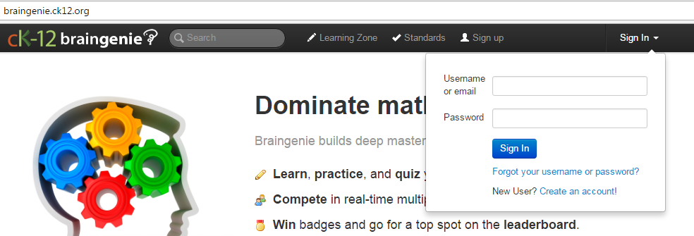

- Go to Goals
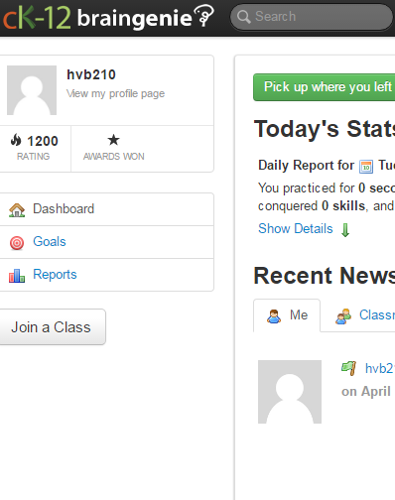

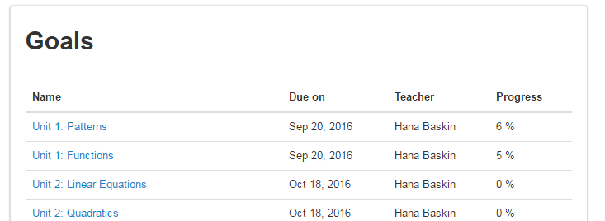
- Go to the correct unit

If you do not have an account:
- Click Sign Up

- Click that you are a student

- Make a Username (such that I will know who it is) and a password
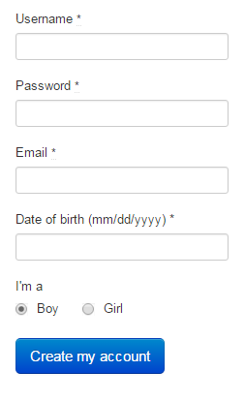

- Click Join a Class

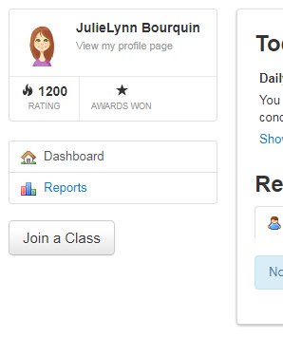
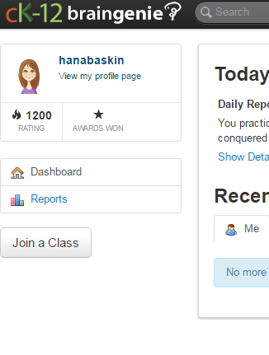

- Enter the correct class code

H. Pre-Calculus
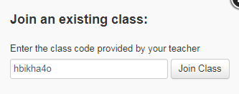

- Click Goals
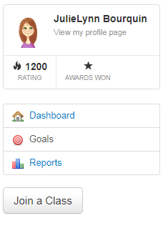

- Choose the correct unit:
