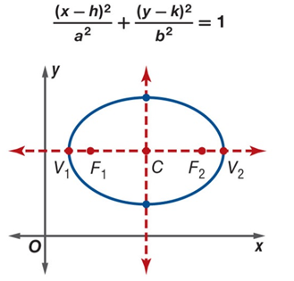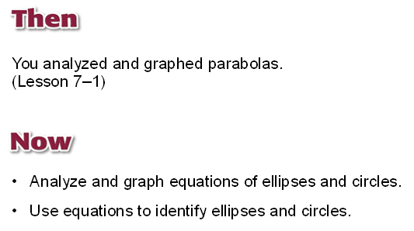

Center

Axis (major and minor)

Vertices (on major axis)

Co-Vertices (on minor axis)

Foci

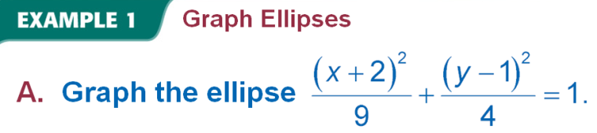
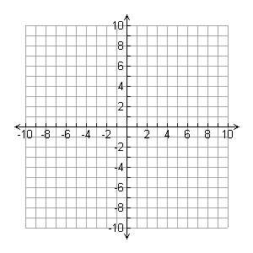
Center

Axis
Major
Minor
Vertices (on major axis)

Co-Vertices (on minor axis)

Foci

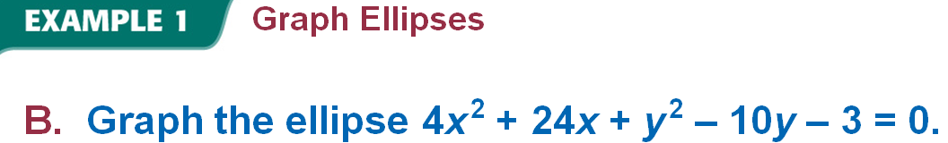

Center

Axis
Major
Minor
Vertices (on major axis)

Co-Vertices (on minor axis)

Foci

For the next few examples, put your work on graph paper.

