Math 1 HW #1 Writing Linear Equations from Tables
Name: ________________________________________

HINT: What 2 things do you need to write in slope-intercept form?

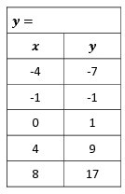
Write the slope-intercept form of the linear relationship displayed in each table below.
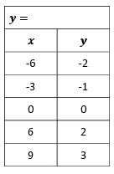
- 2)

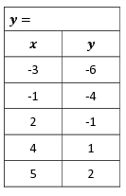
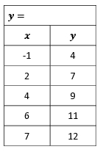
- 4)

