Linear – Multiple Representations

Problem: An amusement park charges a $\$6$ base fee to enter the park and an additional $\$2$ per ride.
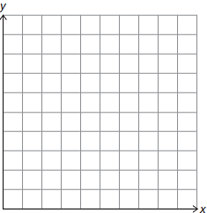
Independent  Variable | Dependent  Variable
x | y
$$0$$
$$1$$
$$2$$
$$3$$
$$5$$
$$8$$
m = _______
b = _______

y = _____________________
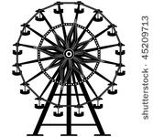

- What is the meaning of the slope in this situation?

- What is the meaning of the y-intercept in this situation?

- How much will it cost to go to the park and ride 3 rides?

- What about 5 rides? 10 rides? 20 rides? 100 rides?

- How many rides can you ride for $\$44$?

