Pre-Calculus Test Review Vectors, Parametric and Polar Equations

- Write the pair of parametric equations x = -2 cos θ and y = 4sin θ in rectangular form.

- Rewrite y = $t^{2}$ + 9 and x = 3t – 1 in rectangular form.

- Use the parameter t = $3x-4$ to determine the parametric equations that can represent y = $x^{2}$ + 5.

- Jose kicked a soccer ball with initial velocity of 85 feet per second at an angle of 52˚ with the ground.
Write parametric equations to represent this situation.

- Graph the curve given by x = -2t + 5 and y = $t^{2}$ over the interval –3 ≤ t ≤ 3?

- A force $F_{1}$ of 12 newtons pulls due north. A force $F_{2}$ of 16 newtons pulls due west. Find the magnitude and direction of the resultant force.

- A constant force of 12 newtons is being applied on an object in the direction of due east at the same time that a constant force of 15 newtons is being applied on the object in the direction of due south. What is the magnitude and direction of the force?

- Each chain is supporting part of the weight of the wooden sign. If the
chain on the left is attached at a 60$°$angle to the horizontal has a force of
10 pounds and the chain on the right is attached at a 57$°$angle to the
horizontal has a force of 8 pounds, then how much does the wooden
sign weigh?

- Graph the polar coordinates ( -2, $\frac{π}{4}) and (3, -310°)$on the given graph.
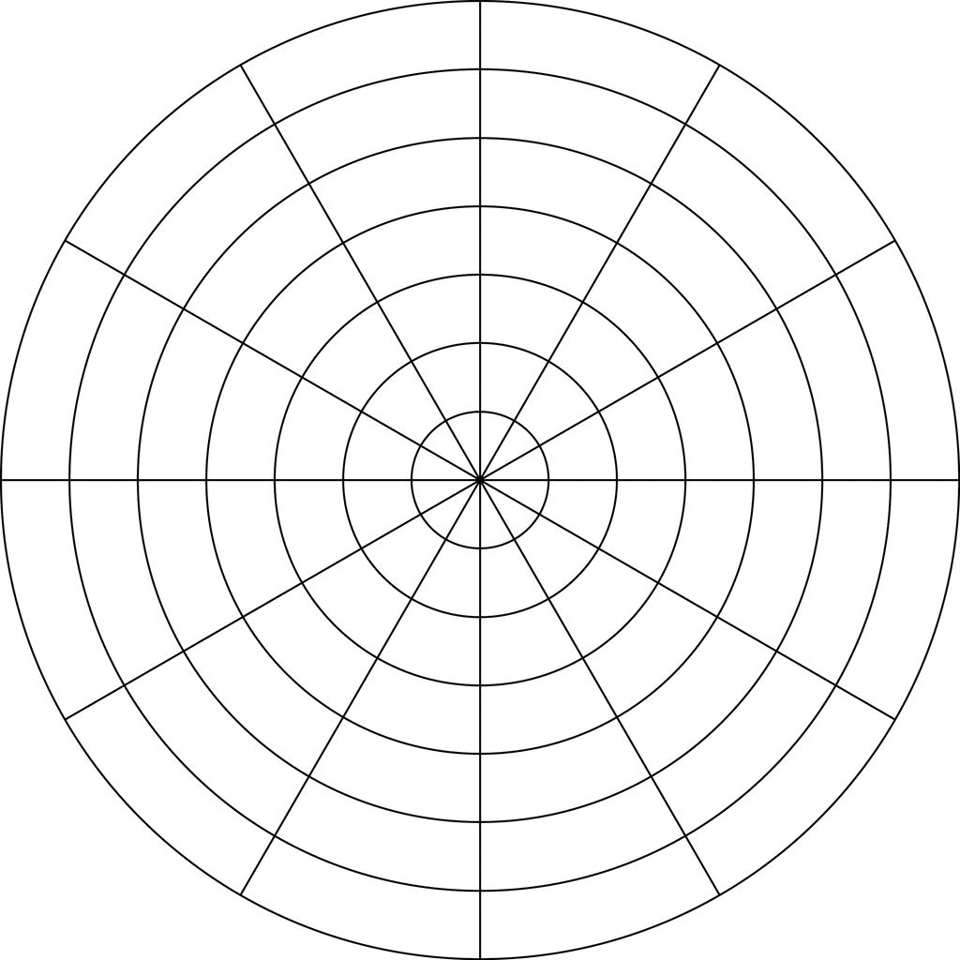

- Graph $r=4 and θ=\frac{π}{3}$

- Graph r = 2 + 2 sin θ.

- Graph the polar equation r = 4 cos θ.

- Find polar coordinates for the point with rectangular coordinates ($\sqrt{2}$ , $\sqrt{2}$) if 0 ≤ θ ≤ 2π and r ≥ 0.

- Given the polar coordinates (2, 90°). Find rectangular coordinates for this point.

- Write the polar equation r = 5 in rectangular form.

- Write the rectangular equation $x^{2}$ + $y^{2}$ – 4x = 0 in polar form.

- Write the polar equation $r^{2}$ – 3r sin θ = 0 in rectangular form.

